CHRONIC PAIN IN CORNWALL
Information for patients

Pain usually alerts us to an injury, like a fire alarm alerting us to a fire.

That’s fine – it tells our body to pay attention to the injury and make us rest and get better.

But sometimes the pain goes on after the injury has healed. Or pain comes out of the blue for no apparent reason. If it goes on for more than 3 months we call it chronic (or persistent / long term) pain. Think of it as a faulty fire alarm – alerting us to danger... except there’s no fire.

Cornwall GPs, pain specialists and, importantly, patients have teamed up to write information which includes video, audio and onward links to other resources to help you manage chronic pain yourselves (with less emphasis on medications) and reduce the impact it has on your lives.

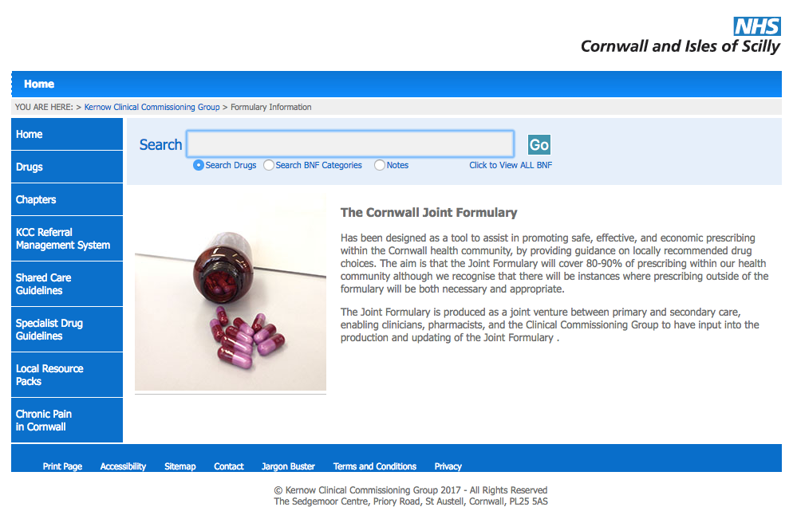
We hope you find it helpful

To find it.... go to

www.eclipsesolutions.org/cornwall

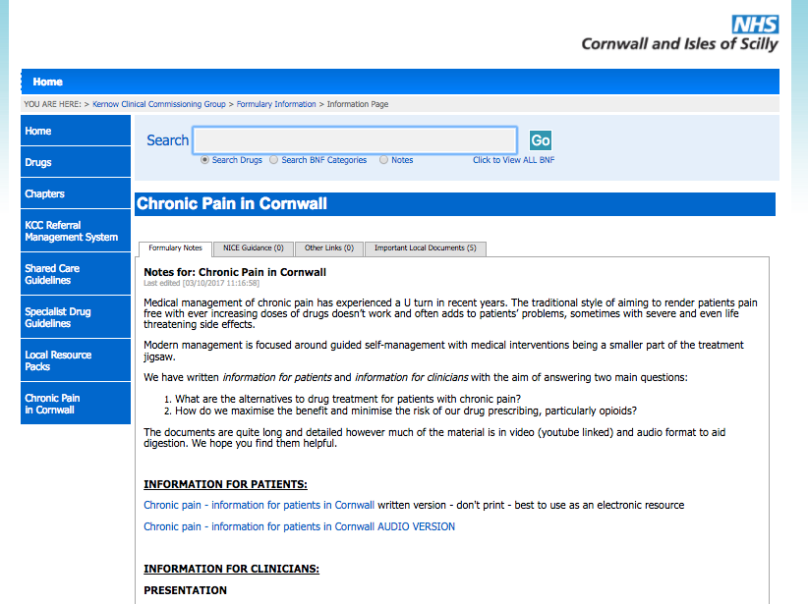
Then follow the link at the bottom
left of the page -
“Chronic pain in Cornwall”

Find the “information for patients” section

